**Console output :**

1. Spring application getting started and xml beans are loaded (1st four lines in red)
2. Retrieving the files from the directory and printed types (FileName,FileSize in Bytes,MimeType,FileExtension) in the console

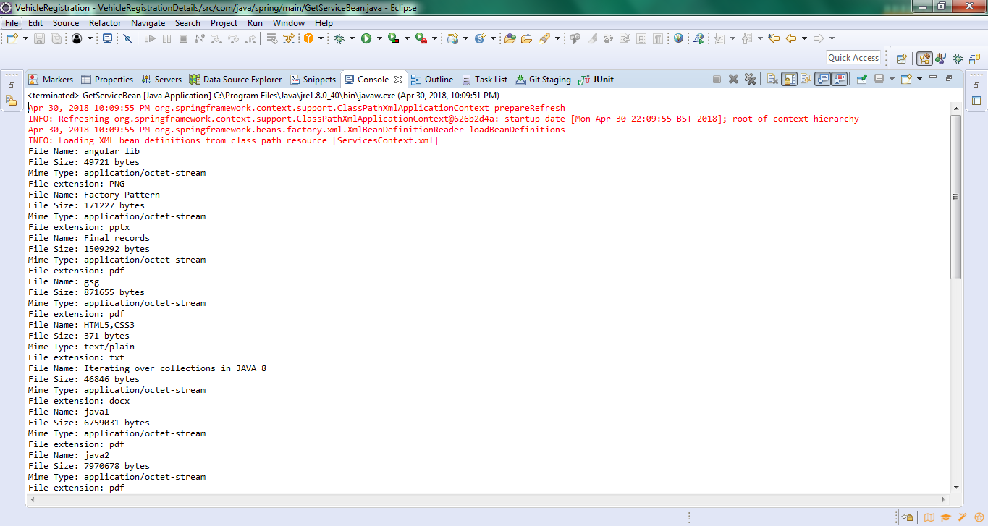

**Console output continuation:**

1. Chrome driver is called and the webpage is opened to perform operations like click, enter
2. The data from csv file and the data from webpage is matched.

